Compte rendu CH2: configuration de base d’un switch

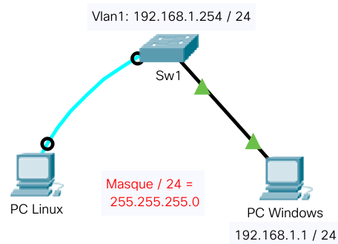
1.Schéma
MDP console: cisco
MDP exécution privilégié: class

Switch>en
Switch#conf t
Enter configuration commands, one per line. End with CNTL/Z.
Switch(config)#hostname Sw1
Sw1(config)#line console 0
Sw1(config-line)#password cisco
Sw1(config-line)#login
Sw1(config-line)#exit
Sw1(config)#enable secret class
Sw1(config)#banner motd "ACCES AUTORISE UNIQUEMENT. VIOLATORS WILL BE PROSECUTED TO THE FULL EXTENT OF THE LAW"
Sw1(config)#exit
Sw1#
%SYS-5-CONFIG_I: Configured from console by console
Sw1#copy running-config startup-config
Destination filename [startup-config]?
Building configuration...
[OK]
Sw1#conf t
Enter configuration commands, one per line. End with CNTL/Z.
Sw1(config)#interface vlan1
Sw1(config-if)#ip address 192.168.1.254 255.255.255.0
Sw1(config-if)#no shutdown
Sw1(config-if)#
%LINK-5-CHANGED: Interface Vlan1, changed state to up
%LINEPROTO-5-UPDOWN: Line protocol on Interface Vlan1, changed state to up
Sw1(config-if)#
Sw1 con0 is now available
Press RETURN to get started.
Identifier un périphérique USB connecté au PC Linux

Dans la console (CTRL+ALT+t)

cdaguenet@b106tu2p3:~$ lsusb
Bus 002 Device 002: ID 8087:0024 Intel Corp. Integrated Rate Matching Hub
Bus 002 Device 001: ID 1d6b:0002 Linux Foundation 2.0 root hub
Bus 001 Device 004: ID 067b:2303 Prolific Technology, Inc. PL2303 Serial Port
Bus 001 Device 002: ID 8087:0024 Intel Corp. Integrated Rate Matching Hub
Bus 001 Device 001: ID 1d6b:0002 Linux Foundation 2.0 root hub
Bus 004 Device 001: ID 1d6b:0003 Linux Foundation 3.0 root hub
Bus 003 Device 003: ID 413c:2003 Dell Computer Corp. Keyboard
Bus 003 Device 002: ID 0461:4d81 Primax Electronics, Ltd Dell N889 Optical Mouse
Bus 003 Device 001: ID 1d6b:0002 Linux Foundation 2.0 root hub
cdaguenet@b106tu2p3:~$ lsusb
Bus 002 Device 002: ID 8087:0024 Intel Corp. Integrated Rate Matching Hub
Bus 002 Device 001: ID 1d6b:0002 Linux Foundation 2.0 root hub
Bus 001 Device 002: ID 8087:0024 Intel Corp. Integrated Rate Matching Hub
Bus 001 Device 001: ID 1d6b:0002 Linux Foundation 2.0 root hub
Bus 004 Device 001: ID 1d6b:0003 Linux Foundation 3.0 root hub
Bus 003 Device 003: ID 413c:2003 Dell Computer Corp. Keyboard
Bus 003 Device 002: ID 0461:4d81 Primax Electronics, Ltd Dell N889 Optical Mouse
Bus 003 Device 001: ID 1d6b:0002 Linux Foundation 2.0 root hub
cdaguenet@b106tu2p3:~$ ls /dev/tty*
/dev/ttyS21 /dev/ttyS27 /dev/ttyS4 /dev/ttyUSB0
/dev/tty10 /dev/tty16 /dev/tty21 /dev/tty27 /dev/tty32 /dev/tty38 /dev/tty43 /dev/tty49 /dev/tty54 /dev/ttyS0 /dev/tty8 /dev/ttyS11 /dev/ttyS17 /dev/ttyS22 /dev/ttyS28 /dev/ttyS5

/dev/ttyUSB0: Câble série avec adaptateur

/dev/ttyS0: Liaison série du PC (connecteur DB9)

Utilisation de Putty SSH Client




